# UI/UX Wireframes Documentation

## Home Page

Purpose: This page serves as the main entry point for users, showcasing featured products, promotions, and easy navigation options.

### Elements:

- A top navigation bar containing the website logo, search bar, and shopping cart icon.

- A section highlighting featured categories and best-selling products.

- Call-to-action (CTA) buttons for special promotions and discounts.

### User Interaction:

- Users can browse and click on products to view details.

- The search bar provides instant product suggestions.

- Clicking on promotions redirects users to relevant product categories.

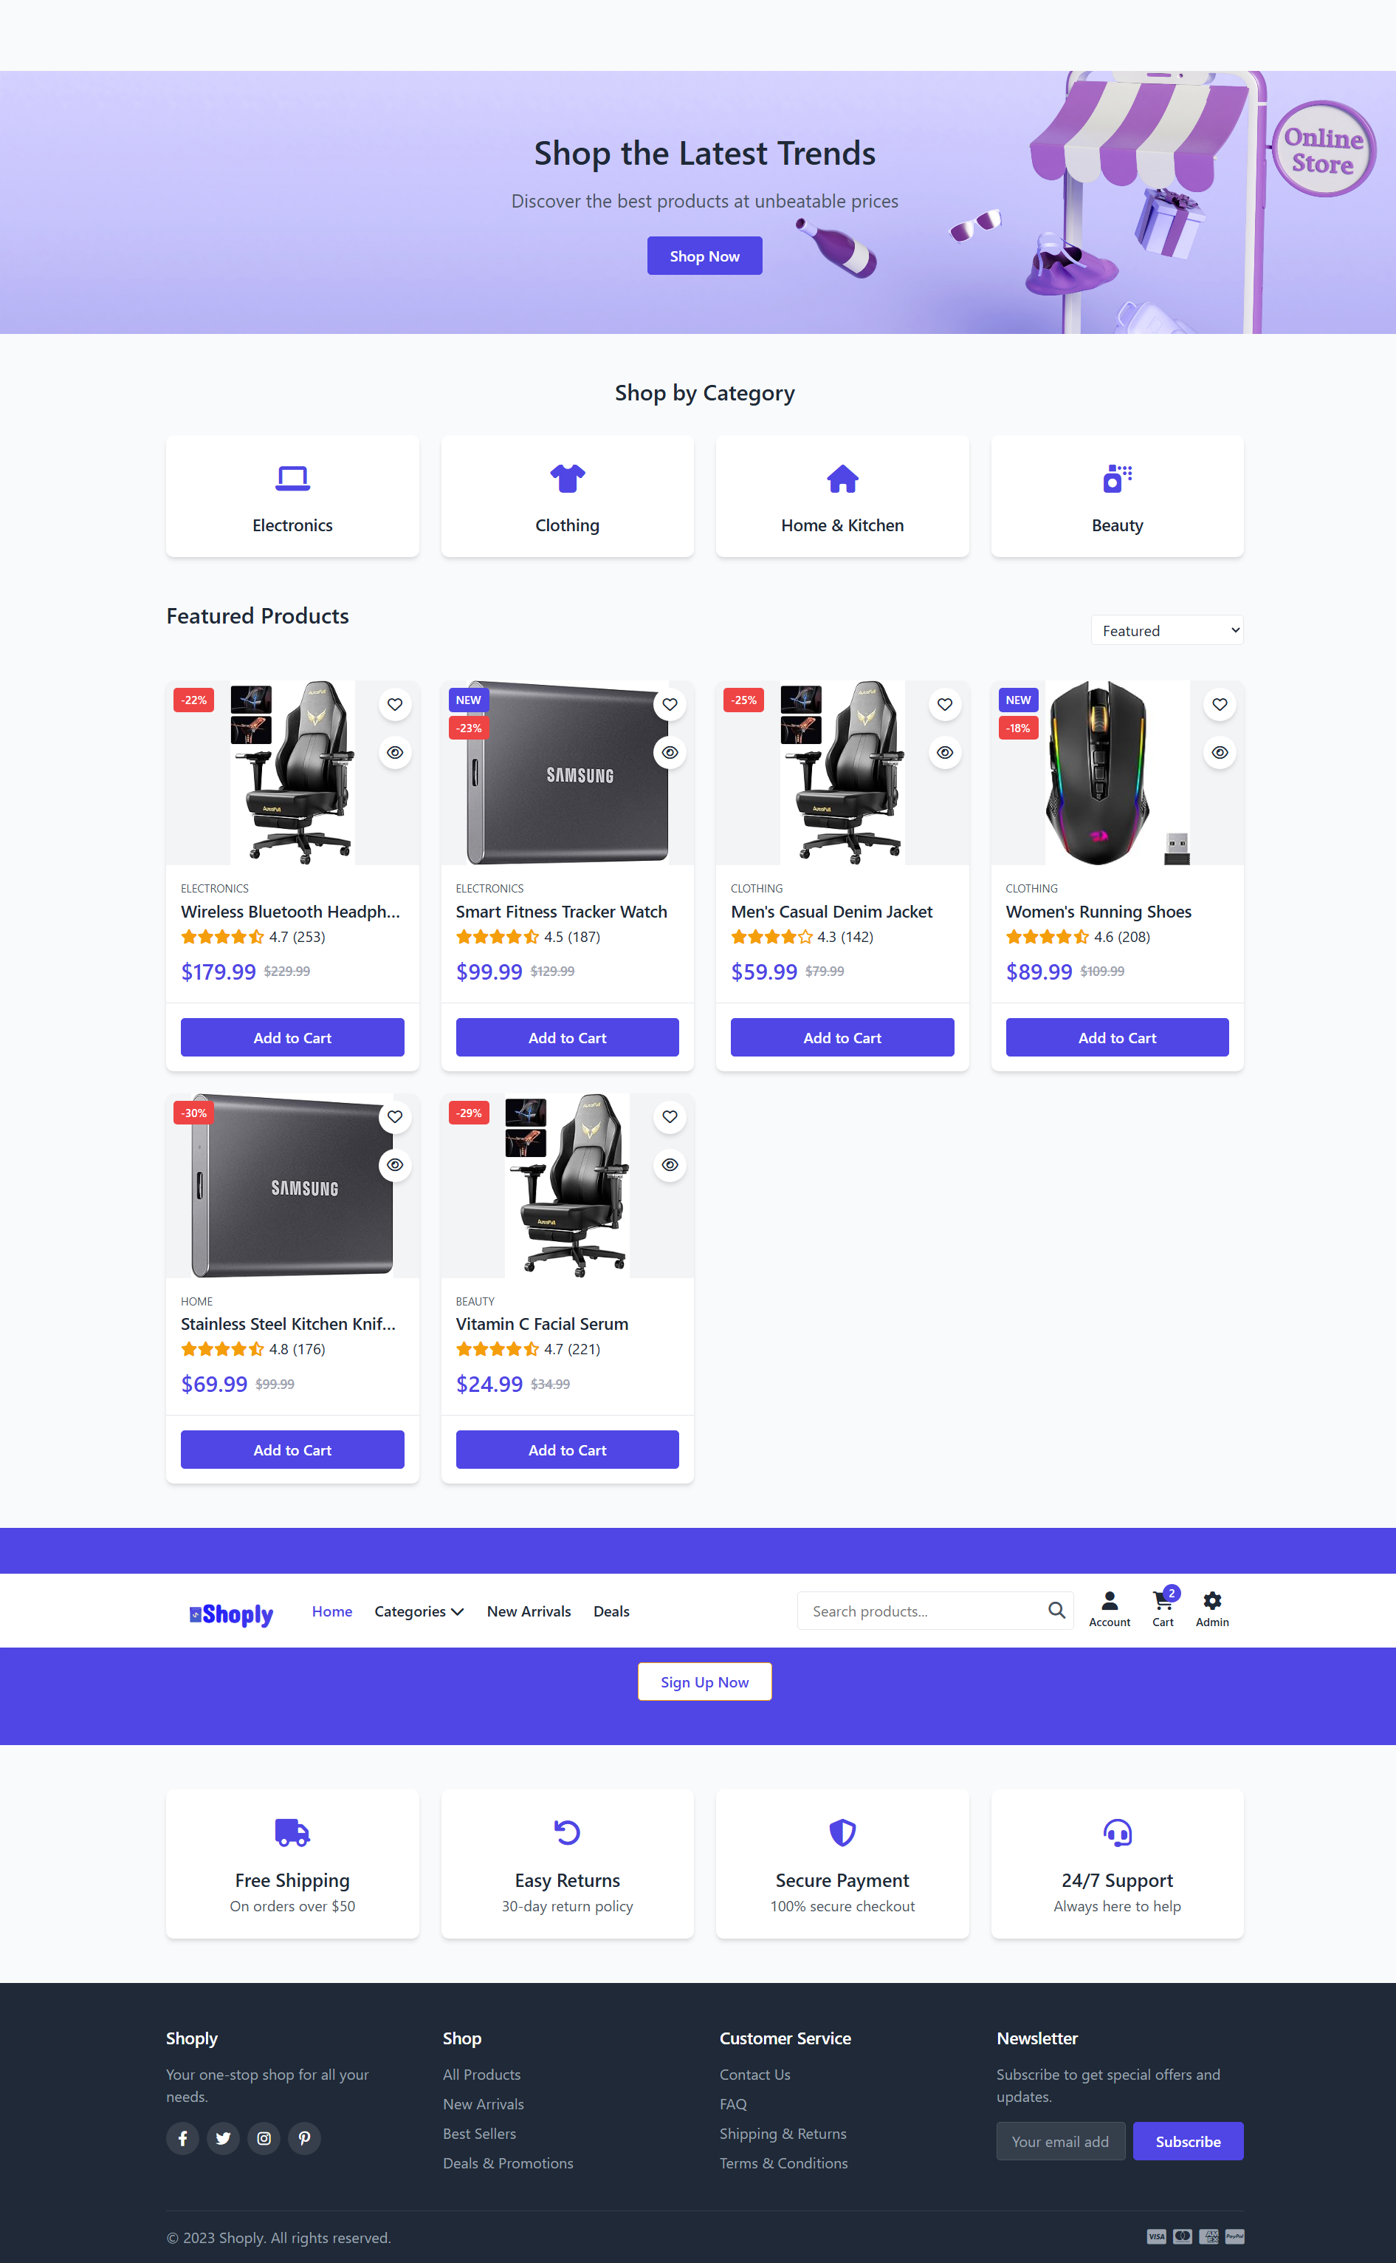

## Login & Registration Page

Purpose: This page allows users to securely log in or register for a new account.

### Elements:

- Fields for entering email/username and password.

- "Forgot Password?" link for account recovery.

- Options for social media login.

- A registration link for new users.

### User Interaction:

- Users enter their credentials and click "Login" to access their account.

- If credentials are incorrect, an error message is displayed.

- Clicking "Register" leads to the sign-up form for new account creation.

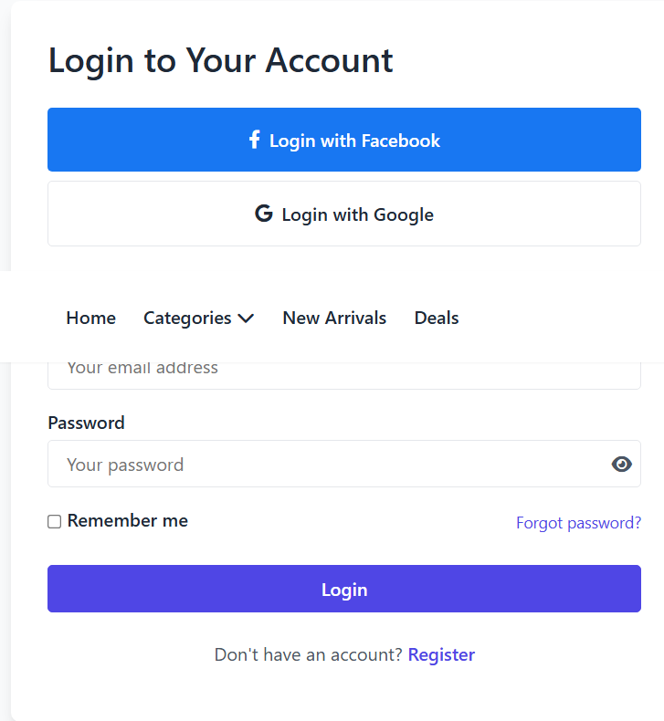

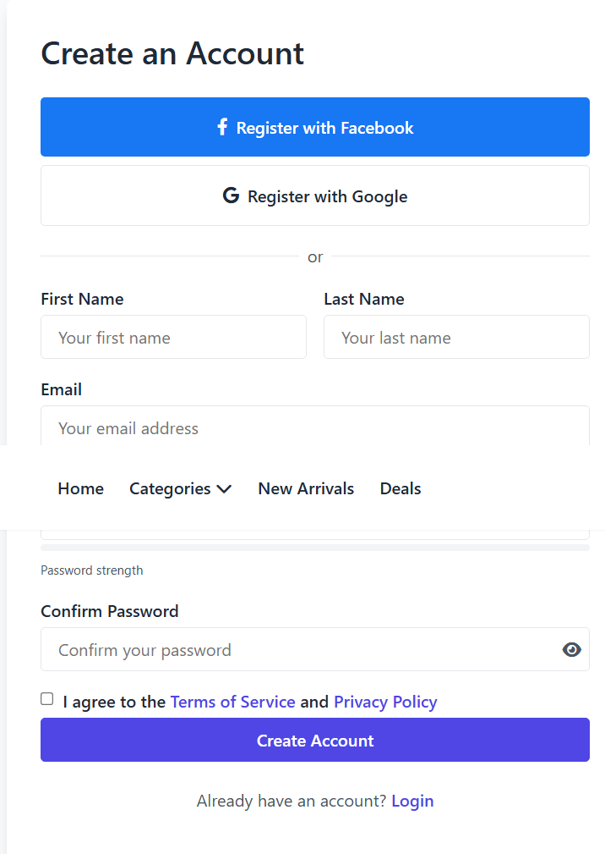

## Product Page

Purpose: Displays detailed information about a selected product, including pricing, images, and customer reviews.

### Elements:

- High-resolution product images with zoom functionality.

- Product title, description, and pricing details.

- Add to Cart and Buy Now buttons.

- Customer reviews and ratings.

### User Interaction:

- Users can add the product to their cart or proceed to checkout instantly.

- Scrolling down shows additional product details and related recommendations.

- Users can select product variations (e.g., size, color) before purchasing.

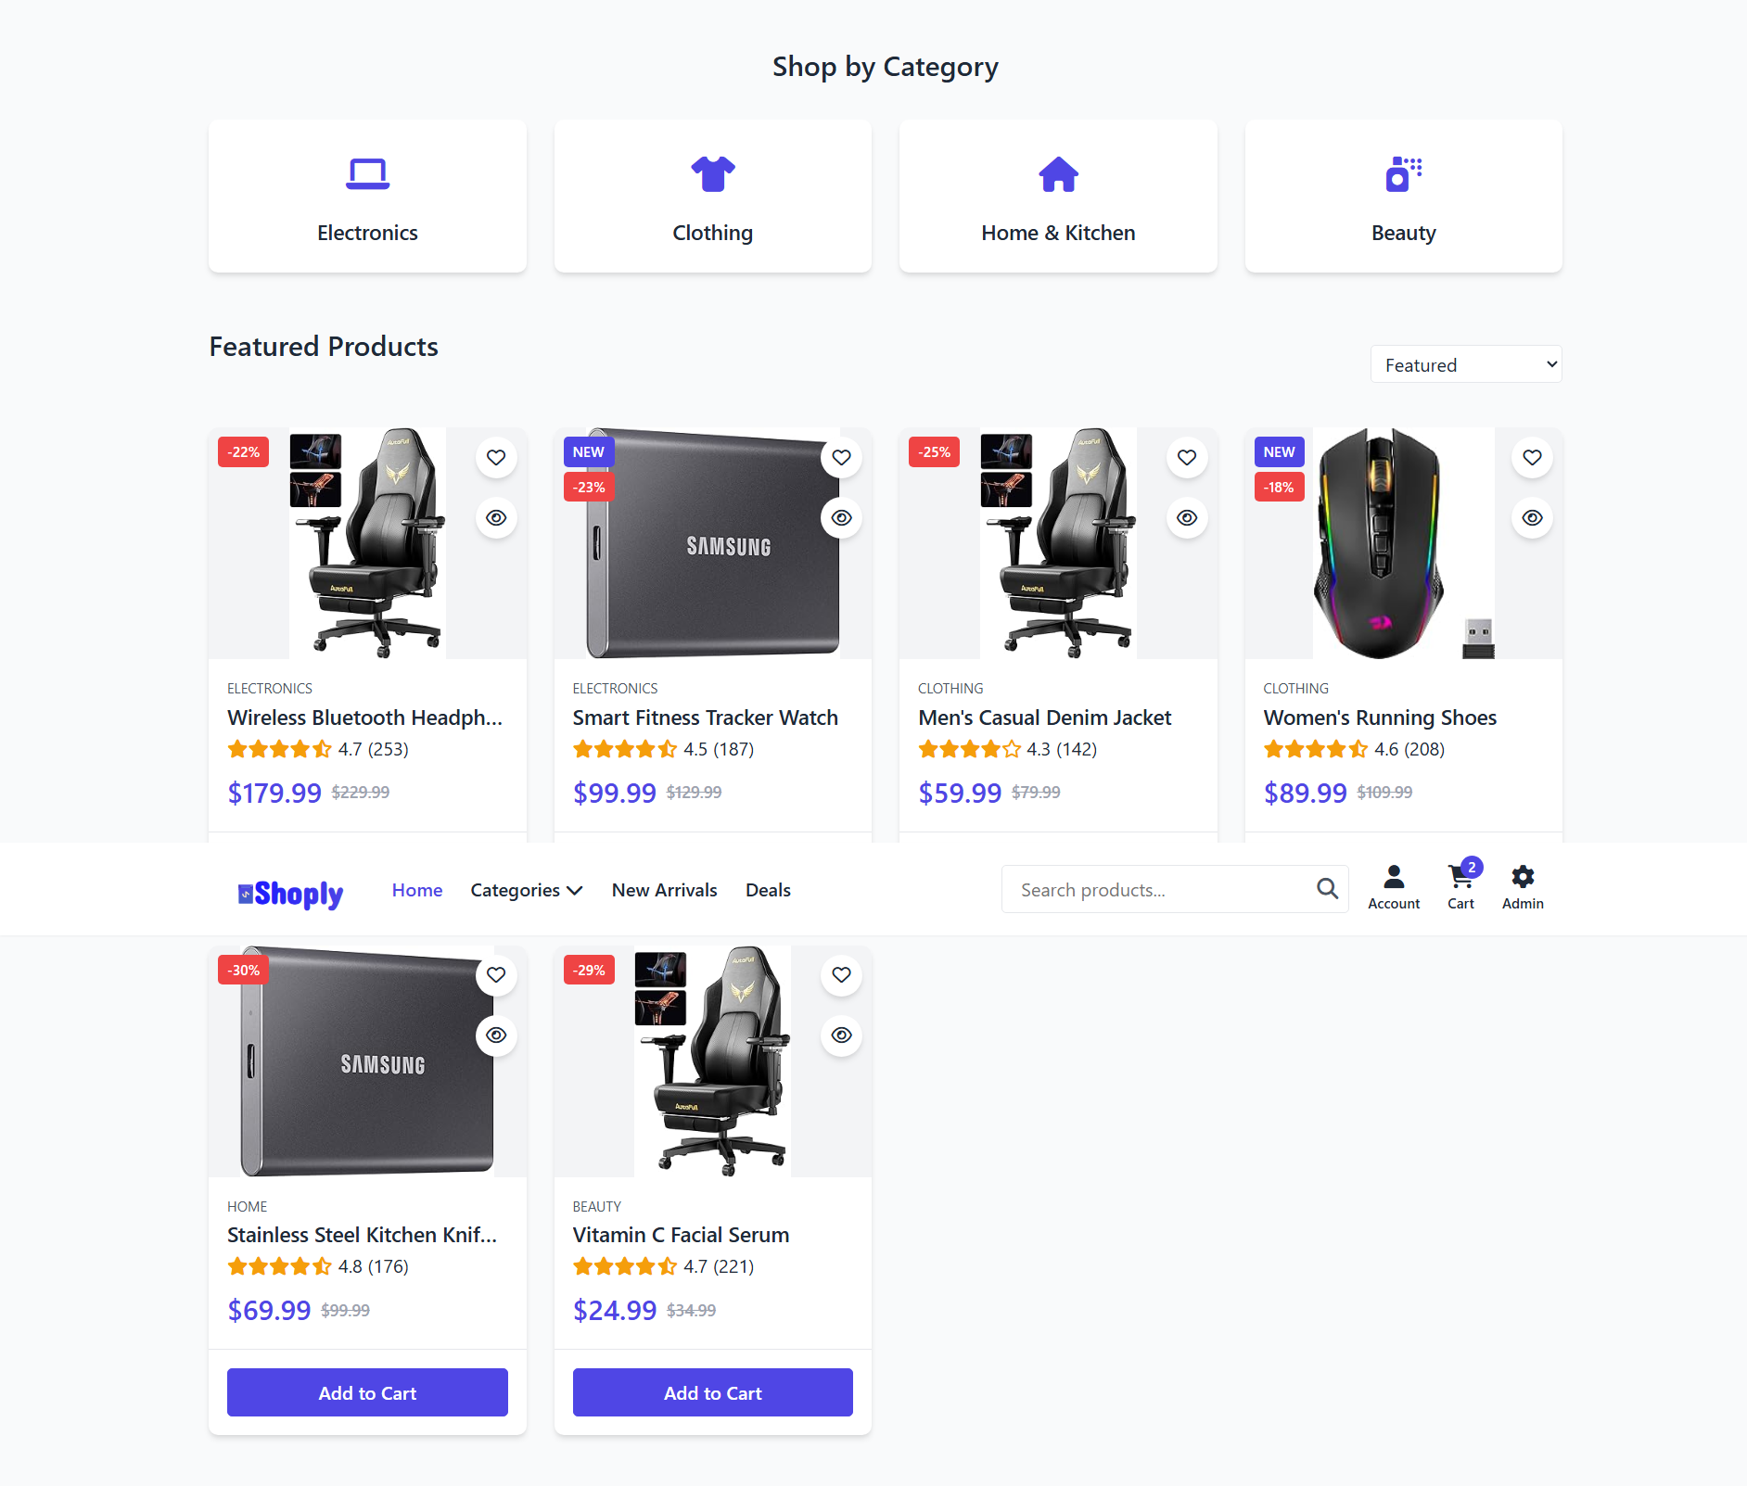

## Shopping Cart

Purpose: Allows users to review and modify their selected items before proceeding to checkout.

### Elements:

- A list of products added to the cart with quantity adjustments.

- An option to remove unwanted items.

- Display of total price, discounts, and applicable taxes.

- A checkout button for completing the purchase.

### User Interaction:

- Users can change item quantities or remove products from the cart.

- Clicking "Checkout" redirects users to the payment and shipping details page.

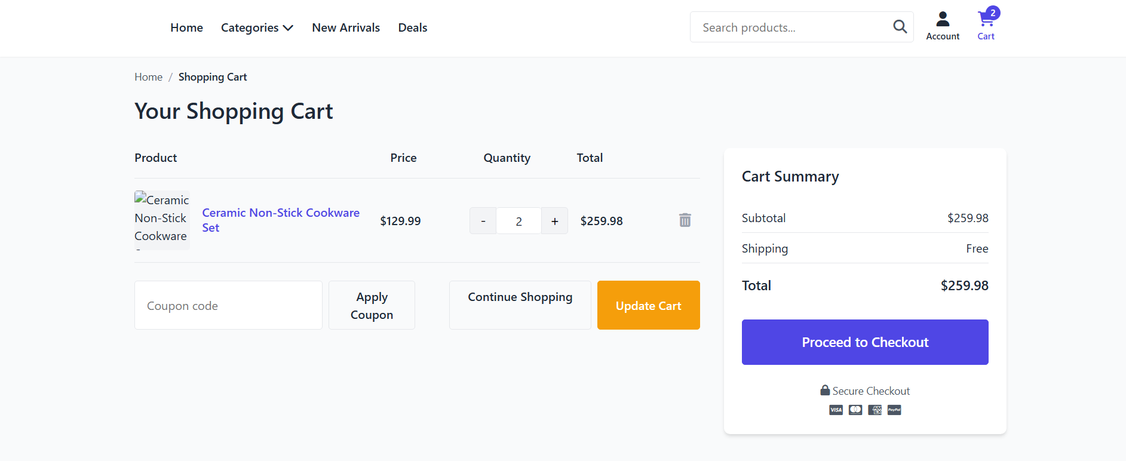

## User Dashboard

Purpose: Provides users with an overview of their account, including order history, saved items, and profile settings.

### Elements:

- A section displaying past orders with real-time status updates.

- Options to update personal information and shipping addresses.

- A wishlist feature for saving favorite items.

### User Interaction:

- Users can track their orders and view invoice details.

- Clicking on a saved product in the wishlist redirects them to its details page.

## Admin Panel

Purpose: The admin dashboard allows store administrators to manage products, orders, and customer accounts.

### Elements:

- A dashboard overview with key sales analytics and order tracking.

- Product management tools for adding, editing, and deleting items.

- User management for monitoring customer accounts and modifying permissions.

- Order management for approving, processing, or canceling orders.

- Store settings to configure payment gateways, tax rates, and general preferences.

### User Interaction:

- Admins can modify product details and update stock levels.

- Orders can be marked as shipped, canceled, or completed.

- Users can be suspended or granted special permissions based on activity.

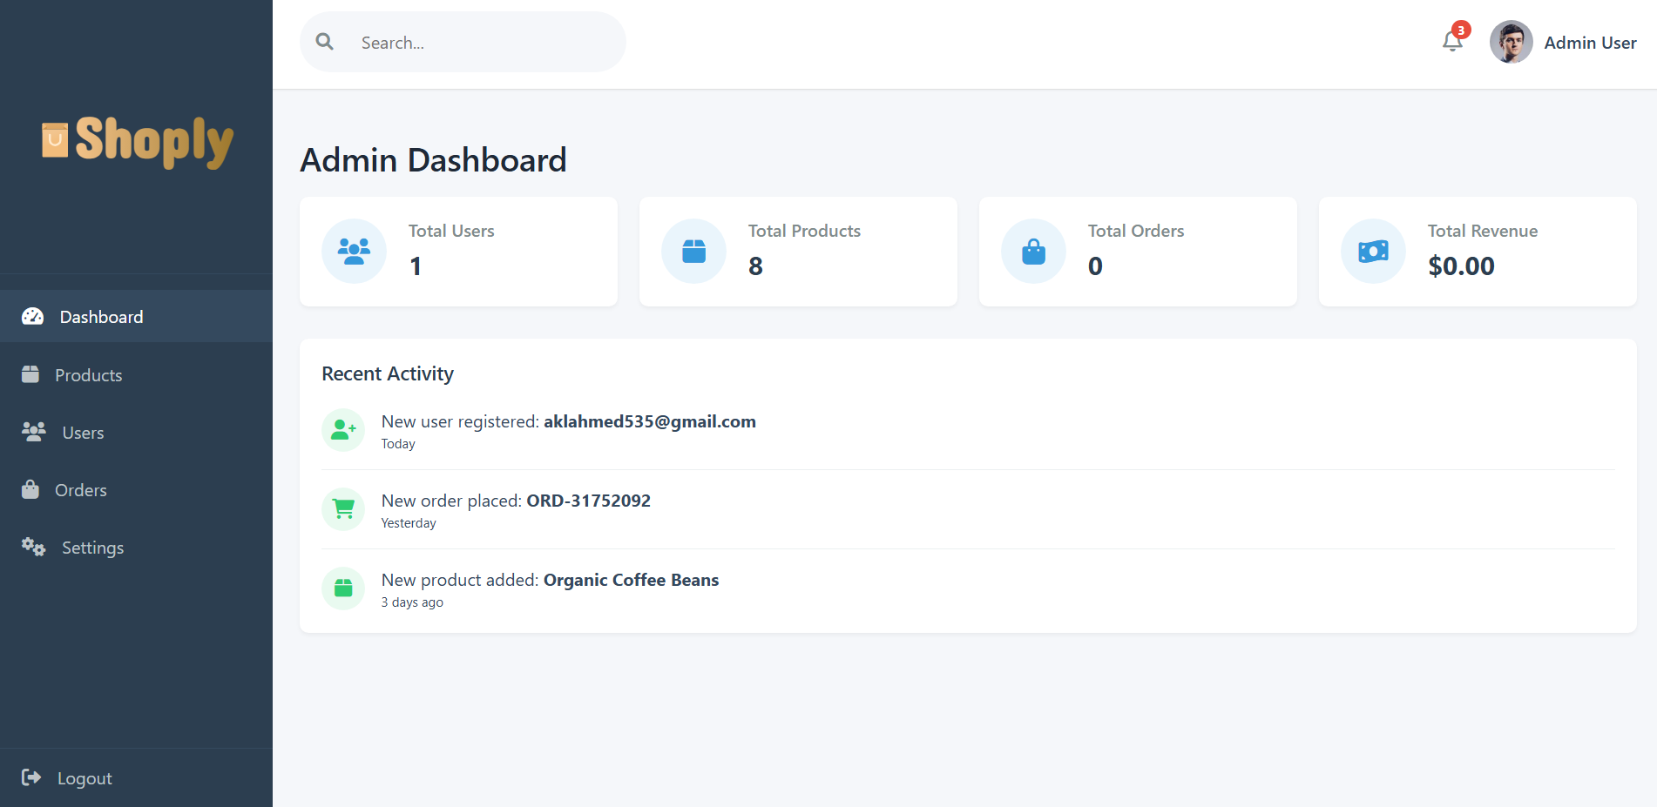

## Conclusion

This document outlines the wireframes and key user interactions for the e-commerce platform. A well-structured UI/UX ensures seamless navigation, user engagement, and smooth transactions, ultimately enhancing the overall shopping experience. Future improvements may include additional personalization features and enhanced recommendation algorithms.